

QBUS5001 Final Exam Practice Questions
Topic 2 - One population inference on population proportion
2024 S2
Tony Shang | Discipline of Business Analytics

0 Introduction

0.1 We value your feedback!
If you’ve found Tony and the teaching team’s support in QBUS5001 helpful, we’d be very grateful if you could take a few moments to share your feedback by completing the following surveys. Your insights mean a lot to us and help us improve the learning experience for everyone!
- Unit of Study Survey (USS) about Tony as QBUS5001 Coordinator:
https://student-surveys.sydney.edu.au/s/uss907510
- Feedback for Teachers (FFT) Survey about Tony as a teacher:
https://student-surveys.sydney.edu.au/s/fft963078
If you printed out the material, you may scan the QR code using your phone camera:
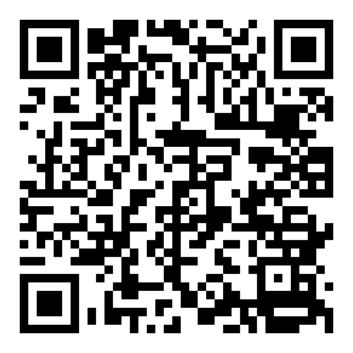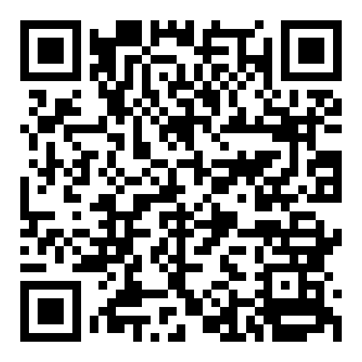
USS Survey FFT Survey
By the way, participating in the surveys gives you a chance to win JB Hi-Fi gift cards!
- 1st Prize: JB Hi-Fi Gift Card ($899.00)
- 2nd Prize: JB Hi-Fi Gift Card ($599.00)
- 3rd Prize: 2 x $200 JB Hi-Fi Gift Cards
- 4th Prize: 6 x $100 JB Hi-Fi Gift Cards
Additional Awards for Participating the surveys
While it’s not Tony's formal responsibility to provide sample papers, I understand the value they add to your preparation. In return for your survey participation, here’s what I’ll provide:
- 20% participation in USS and FFT: 1 sample paper (already achieved!)
- 40% participation in USS and FFT: 2 sample papers
- 60% participation in USS and FFT: 3 sample papers
- 80% participation in USS and FFT: 5 sample papers
- 99% participation in USS and FFT: 10 sample papers
Thank you for your time and support – it truly makes a difference!

0.2 Context
Welcome to Wacky Tony’s Fries (WTF), the quirkiest fast-food joint in town, where Tony is on a mission to redefine the world of fries! Known for his experimental flavours and colossal portion sizes, Tony’s goal is to make fries that are bigger, spicier, and crunchier than anything you’ve ever tasted. From "MegaFries" that stretch a foot long to "GigaWedges" with jaw-dropping thickness, each product promises a unique experience for the brave and the curious.
Let’s dive into some statistical analyses to support Tony’s vision for Wacky Tony’s Fries.

2 One population inference on population proportion

Sample question 2
After receiving customer feedback, Tony claims that 80% of customers rate his 'MegaFries' as “Mega.” However, a local critic believes the true proportion might be different.
- [3 marks] Before collecting data, Tony wants to ensure his sample size is large enough to estimate the true proportion of customers who rate MegaFries as “Mega” within a 4% margin of error at a 95% confidence level. Assuming the true proportion is around 80%, calculate the minimum sample size required. Show all calculations clearly. (use $z_0.025 = 1.96$)
The required sample size is given by
$$n={\left(\frac{z_{0.025}⋅\sqrt{p⋅\left(1-p\right)}}{E}\right)}^{2}\text{[1 mark]}$$
$$n={\left(\frac{1.96⋅\sqrt{0.80⋅0.20}}{0.04}\right)}^{2}=(19.6)^{2}=384.16≈385 \text{[1 mark]}$$
So, the minimum sample size required is 385. [1 mark]
- [4 marks] Tony surveys 500 customers and finds that 390 rate MegaFries as “Mega.” Construct a 95% confidence interval for the true proportion of customers who rate MegaFries as “Mega.” Show all calculations and interpret the result in the context of the problem. (use $z_0.025 = 1.96$)
The confidence interval is given by
$$\hat{p}±z_{0.025}⋅\sqrt{\frac{\hat{p}⋅(1-\hat{p})}{n}}\text{[1 mark]}$$
The lower confidence limit is
$$\text{LCL}=0.78-1.96⋅\sqrt{\frac{0.78⋅0.22}{500}}=0.7437\text{[1 mark]}$$
The upper confidence limit is
$$\text{UCL}=0.78+1.96⋅\sqrt{\frac{0.78⋅0.22}{500}}=0.8163\text{[1 mark]}$$We are 95% confident that the true proportion of customers who rate MegaFries as “Mega” falls between 74.37% and 81.63%. [1 mark]
- [7 marks] Tony wants to test whether the true proportion of customers who rate MegaFries as “Mega” is different from his claimed 80%. Conduct a two-tailed hypothesis test at the 5% significance level. (Perform a full hypothesis test; use $z_0.025 = 1.96$)

Test
$$H_{0}:p=0.80$$
$$H_{1}:p≠0.80 \text{[1 mark]}$$
Since $np=500×0.8=400>5, n\left(1-p\right)=500×0.2=100>5$, the sampling distribution of sample proportion can be approximated by a normal distribution. [1 mark]
Under $H_{0}$​, the test statistic is given by
$$Z=\frac{\hat{p}-p}{\sqrt{\frac{p⋅(1-p)}{n}}}\text{\sim N(0,1) }\text{[1 mark]}$$
At the 5% level of significance, the null hypothesis is rejected if
$$∣Z∣>1.96 \text{[1 mark]}$$
The observed value of the test statistic is given by
$$Z=\frac{0.78-0.80}{\sqrt{\frac{0.80⋅0.20}{500}}}=-1.117 \text{[1 mark]}$$
Since $-1.96<-1.117<1.96$, $H_{0}$ is not rejected at the 5% level of significance. [1 mark]
There is not enough evidence to conclude that the true proportion of customers who rate MegaFries as "Mega" is different from 80%. [1 mark]

Practice Question 2.1
Tony believes that 60% of customers enjoy his new 'Spicy Inferno Fries.' However, after a few negative reviews, Tony starts to question if the true enjoyment rate might be different.
- [3 marks] Before collecting data, Tony wants to determine the sample size required to estimate the true proportion of customers who enjoy Spicy Inferno Fries within a 5% margin of error at a 95% confidence level, assuming the proportion is around 60%. Calculate the minimum sample size required. Show all calculations clearly. (use $z_0.025 = 1.96$)

- [4 marks] Tony surveys a random sample of 400 customers, finding that 220 say they enjoy the Spicy Inferno Fries. Construct a 95% confidence interval for the true proportion of customers who enjoy Spicy Inferno Fries. Show all calculations and interpret the result. (use $z_0.025 = 1.96$)

- [7 marks] Tony wants to test if the true proportion of customers who enjoy Spicy Inferno Fries is different from his claimed 60%. At the 5% significance level, conduct a two-tailed hypothesis test. (Perform a full hypothesis test; use $z_0.025 = 1.96$)

Practice Question 2.2
Tony claims that 40% of customers prefer his “Colossal Curly Fries” for their unique curliness. However, his marketing team suspects the true proportion could be higher.
- [3 marks] Before collecting data, Tony wants to ensure his sample size is large enough to estimate the true proportion of customers who prefer Colossal Curly Fries for their curliness within a 6% margin of error at a 95% confidence level. Assuming the true proportion is around 40%, calculate the minimum sample size required. Show all calculations clearly. (use $z_0.025 = 1.96$)

- [4 marks] Tony surveys 250 customers, and 115 of them say they prefer the Colossal Curly Fries for their curliness. Construct a 95% confidence interval for the true proportion of customers who prefer Colossal Curly Fries for their curliness. Show all calculations and interpret the result in context. (use $z_0.025 = 1.96$)

- [7 marks] Tony wants to test if the true proportion of customers who prefer Colossal Curly Fries for their curliness is higher than his claimed 40%. Conduct a one-tailed hypothesis test at the 5% significance level. (Perform a full hypothesis test; use $z_0.025 = 1.96$)

Practice Question 2.3
Tony claims that 25% of his GigaWedges are rated by customers as “Extra Crispy.” However, after observing a few feedback sessions, he suspects the true proportion could be lower.
- [3 marks] Before collecting data, Tony wants to determine the sample size required to estimate the true proportion of GigaWedges rated as “Extra Crispy” within a 4% margin of error at a 95% confidence level, assuming the true proportion is around 25%. Calculate the minimum sample size required. Show all calculations clearly. (use $z_0.025 = 1.96$)

- [4 marks] Tony surveys a random sample of 300 customers, and 66 of them rate the GigaWedges as “Extra Crispy.” Construct a 95% confidence interval for the true proportion of customers who rate GigaWedges as “Extra Crispy.” Show all calculations and interpret the result in the context of the problem. (use $z_0.025 = 1.96$)

- [7 marks] Tony wants to test if the true proportion of customers rating GigaWedges as “Extra Crispy” is lower than his claimed 25%. Conduct a one-tailed hypothesis test at the 5% significance level. (Perform a full hypothesis test; use $z_0.025 = 1.96$)

Practice Question 2.4
Tony proudly claims that 70% of customers who try his “Jumbo Fry Bites” would purchase them again. However, a competitor believes that the true proportion is actually lower.
- [3 marks] Before collecting data, Tony wants to ensure his sample size is large enough to estimate the true proportion of customers who would repurchase Jumbo Fry Bites within a 5% margin of error at a 95% confidence level, assuming the true proportion is around 70%. Calculate the minimum sample size required. Show all calculations clearly. (use $z_0.025 = 1.96$)

- [4 marks] Tony surveys 400 customers, and 260 of them say they would purchase Jumbo Fry Bites again. Construct a 95% confidence interval for the true proportion of customers who would repurchase Jumbo Fry Bites. Show all calculations and interpret the result in the context of the problem. (use $z_0.025 = 1.96$)

- [7 marks] Tony wants to test if the true proportion of customers who would repurchase Jumbo Fry Bites is lower than his claimed 70%. At the 5% significance level, conduct a one-tailed hypothesis test. (Perform a full hypothesis test; use $z_0.025 = 1.96$)

